Solution Design Document
V1.0
Client Confidential

Occupational Absence Recording, Online Timesheet Claims and Leave Management

Document Control

Document Sign-Off
Refer to the document cover sheet for official signatories.

Version History
Initial internal drafts are versioned 0.0.z (e.g. 0.0.1) and are increased to 0.y.0 (e.g. 0.1.0) when internally approved and ready for issue to the client project team where applicable. When the document is approved by all of the following, the version number increases to x.0.0 (e.g. 1.0.0):
- Client project team; and
- The Access Group.

Version | Date | Author | Details
0.1 | Oct-2020 | Di Phillips | Draft
0.2 | Dec-2020 | Di Phillips | Changes after Initial Review
0.3 | Jan-2021 | Di Phillips | Changes during SIT
0.4 | Nov-2021 | Richard Quarmby | Changes after UAT
0.5 | Dec-2021 | Richard Quarmby | Changes after Live Running
0.6 | Jan-2022 | Richard Quarmby | Changes after Live Running
1.0 | Apr-2022 | Nick Bellars | Baselined Final Version

Document Control 2
Document Sign-Off 2
Version History 2
Overview 5
Pilot Departments 5
Introduction 6
1. Reference Data Configuration 7
1.1 Company Details 7
1.1.1 Company Maintenance 7
1.2 Calendar 8
1.2.1 System Calendar 8
1.2.2 User Defined Calendar 9
1.3 Pay Codes 10
1.3.1 Occupational Absence Recording only and Leave Management Pay Codes 10
1.3.2 Online Timesheet Claims Pay Codes 14
1.4 Reason Codes 16
1.5 Personalised Pay Code Groups 17
1.6 WTD – Pay Codes 19
1.7 MSS Summary 20
1.8 Work Patterns 21
1.9 Shift Types 22
1.10 Work Groups 23
1.11 Balances 25
1.11.1 Balances with Entitlements 25
1.11.2 Balances with Accruals 26
1.11.3 Long Service Awards 27
1.11.4 Pro rata entitlements 27
1.12 Holiday Schemes 28
1.13 Balance Year End 29
2. Person Configuration 30
2.1 Person Overrides 30
2.2.1 Holiday Scheme Override – Back Office 30
2.2 Person Additional Configuration for Time - Portal 30
2.2.1 Personalised Pay Code Groups 30
2.2.2 Shift Type 30
2.2.3 Balance Entitlement 30
2.2.4 Absence Category 31
2.3 Organisational Roles by Person 31
2.4 Menu Profiles 31
2.4.1 Manager Menu Profiles 31
PILOT MANAGERS 32
2.4.2 Employee Menu Profiles 32
2.5 CoreTime System Users 33
3. Generate Timesheets 34
3.1 Approval Process 34
3.2 Sign Off Process 35
3.2.1 Admin Sign Off in Portal 35
3.3 Ignore Unconfirmed Hours (Un-Signed off Hours) 36
3.4 Generate Timesheet – inc. Ignore Unconfirmed Hours 36
3.4.1 Generate Timesheet – Test Mode 36
3.4.2 Generate Timesheet – LIVE Mode 37
4. Occupational Absence 38
5 Portal Configuration 39
5.1 Employee Dashboard 39
5.1.1 Book Leave 39
5.1.2 Balance 40
5.1.3 Timesheet 40
5.2 Manager Dashboard 42
5.2.1 Home Tab 42
5.2.2 Timesheet Tab 43
5.2.3 Delegation 44

Overview
This document has been written to detail the customer specific configuration required to implement the Workforce Management module of People XD from the Access Software Suite at 5 pilot sites at the University of Oxford.
The broad in-scope processes are as follows:
- Occupational Absence
- Leave Management
- Leave Management (Accruals)
- Online Timesheet Claims

Pilot Departments
Throughout the Discovery process, the following departments have been confirmed as pilot groups:
- Classics
- BDI-NDM
- Oxford Ludwig Institute NDM
- Physics – Lab Demonstrators
- Human Resources

The breakdown of employees in each pilot site is as follows:
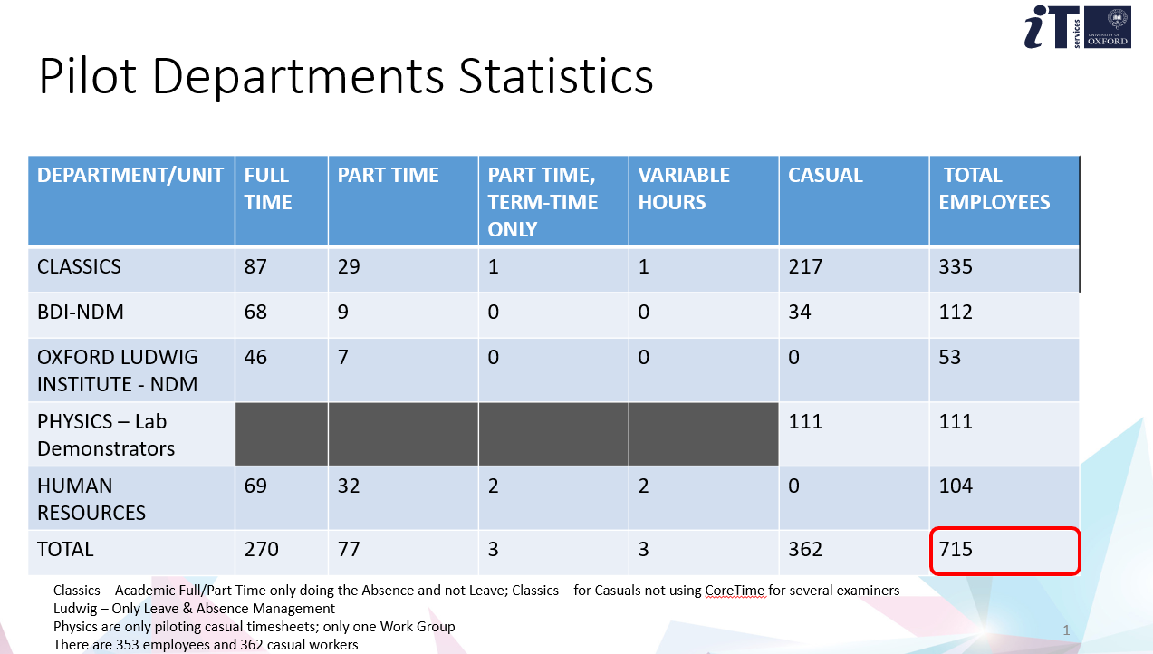
Full Time/Part Time, Part Time Term Time employees having the Occupational Absence and Leave Management functionality.
Variable Hours and Casual employees having Leave Management (Accrual) and Online Timesheet Claims functionality.

Introduction
Oxford University are introducing Occupational Absence, Leave Management and Online Timesheet Claims to four Departments within Oxford.
Full Time/Part Time, Part Time Term Time employees having the Occupational Absence and Leave Management functionality.
Variable Hours and Casual employees having Leave Management (Accrual) and Online Timesheet Claims functionality.
During the Discovery Process, Reference Data was gathered from the University to be used within the configuration of the system.
The remainder of this document describes how that data has been utilised in the configuration and where areas of the system link to other areas of the system.

1. Reference Data Configuration

1.1 Company Details
The Company details determine the name of the Time Company and the ‘Day’ of the week in which Schedules begin.
Oxford have confirmed that the start day of the week is a Monday.

The Company has been configured as follows:
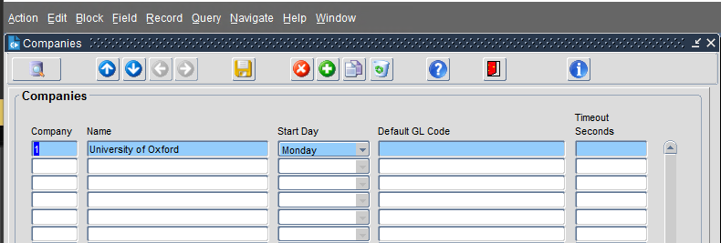

1.1.1 Company Maintenance
The Company will not require any future Maintenance.

1.2 Calendar

1.2.1 System Calendar
The System Calendar underpins the system and is probably the most important area of the system to maintain.
The System Calendar is used within the following areas of the system:
- System Calendar, which would be used by any weekly paid employees,
- Team Scheduler in Portal, ensuring the Team Scheduler opens on the real time week on a Monday
- Timesheet in Portal, ensuring employees see Monday as the beginning of the week
- Shift Type Reference Data, ensuring all Shift Types configured begin on a Monday

Navigation: CoreTime/Roster > System Params > Calendar
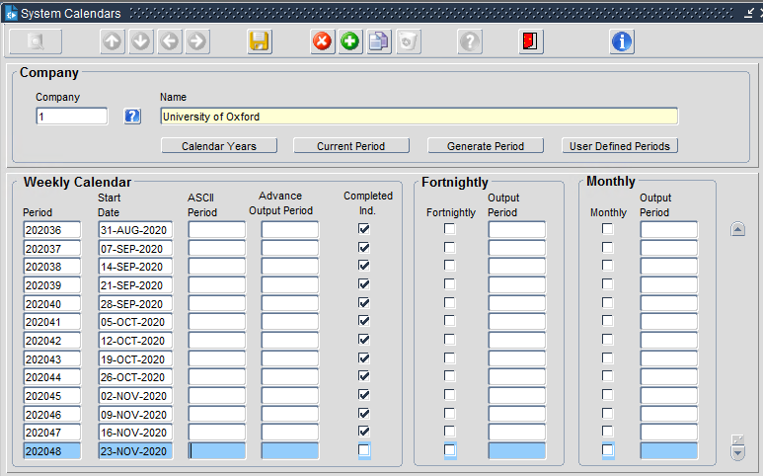

1.2.1.1 System Calendar Maintenance
The System Calendar has been extended until the end of 2022. Beyond this, the calendar will require extension into the future. It is recommended that this calendar is extended yearly as part of the balance year end process.

1.2.2 User Defined Calendar
In addition to the System Calendar, Oxford have requested the use of a User Defined Calendar (UDC). The UDC is used in the following areas of the system:
- Work Group to ensure that all employees contained in a Work Group that is configured as a UDC Work Group have their Online Timesheet Claims paid in accordance to the open calendar period
- Approval Process, ensuring any timesheets requiring Approval are visible
- Sign Off Process, ensuring any timesheets requiring Approval are visible
- Generate Timesheet, ensuring only timesheets for the open calendar period are transferred from CoreTime to CorePay for payment.

The UDC has been configured as follows:
Navigation: CoreTime/Roster > System Params > Calendar > User Defined Periods
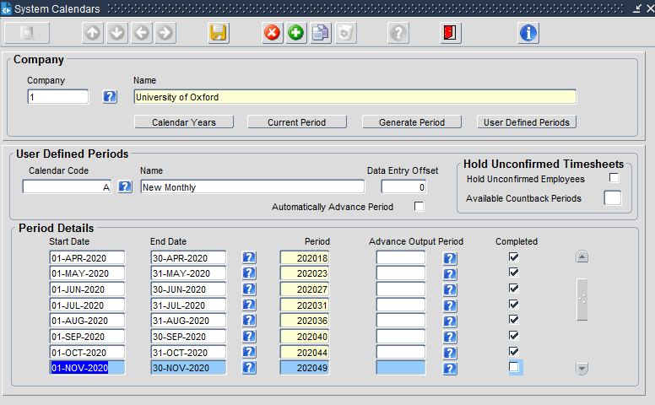

1.2.2.1 User Defined Calendar Maintenance
As with the System Calendar, the UDC has been extended out to 2022, but will require extension by Oxford post this period. It is recommended that this calendar is extended yearly as part of the balance year end process.

1.3 Pay Codes
The University of Oxford is already utilising the People Management and Payroll Modules. There are existing Pay Codes within the system that have now been introduced into CoreTime as a result of the project.

For the purpose of this document, the Pay Codes have been split out into two categories:
- Occupational Absence Recording only, and Leave Management
- Online Timesheet Claims

1.3.1 Occupational Absence Recording only and Leave Management Pay Codes
To support the new functionality for the Occupational Absence and the Leave Management, each set of Pay Codes has been configured slightly different depending on the employees’ status.
ie: if employees are paid via Timesheet, or if employees have an Annual Salary within the system, whereby, the Pay Code is only used to update Balances.

1.3.1.1 Leave Management Pay Codes
There are four Leave Pay Codes that have been configured to accommodate the booking of Annual Leave.
- 3700 – Annual Leave, used in Balances for Salaried Employees
- 329 – Holiday Pay in Hours, used for Variable Hours Employees
- 4231- Cas Holiday Pay Hours, used when Casual Employees are booking leave for GL work
- 4232 – Cas PR Holiday Pay Hours, used when Casual Employees are booking leave for PR work

Each of the above have slightly differing parameters set on in terms of if they should affect pay.
Below is an example of the set up for a non-pay affecting Annual Leave Pay Code.

Navigation:
CoreTime/Roster > System Params > Pay Codes
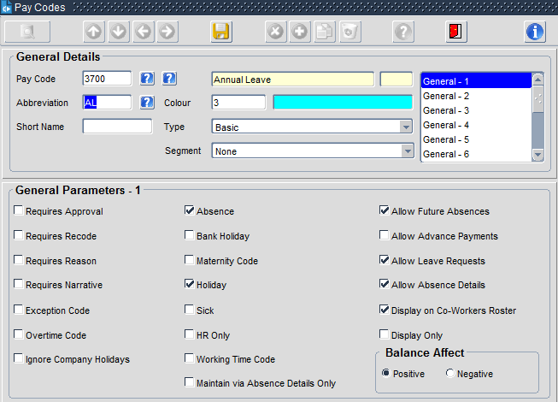
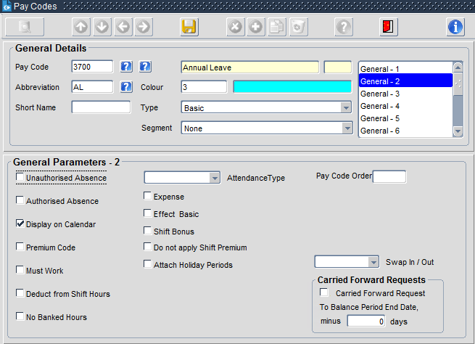
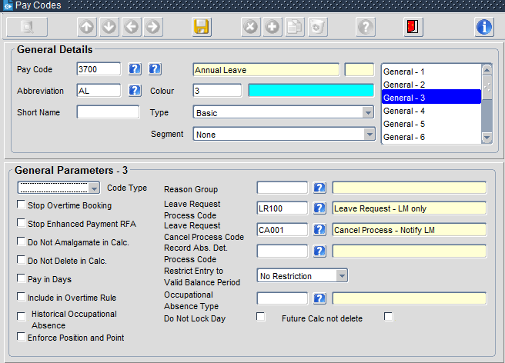
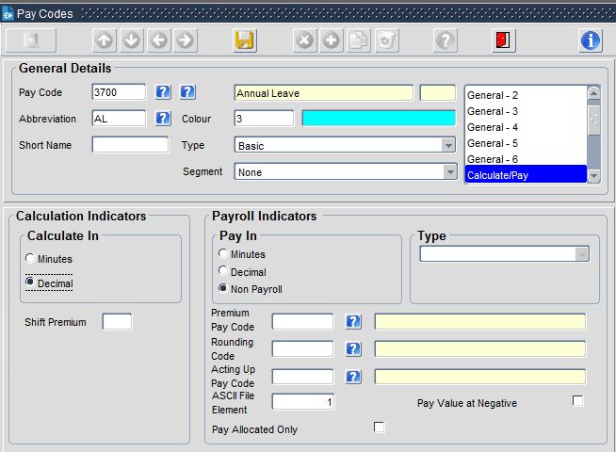
Below is an example of the Pay Code setting to be used where the hours booked should affect pay.
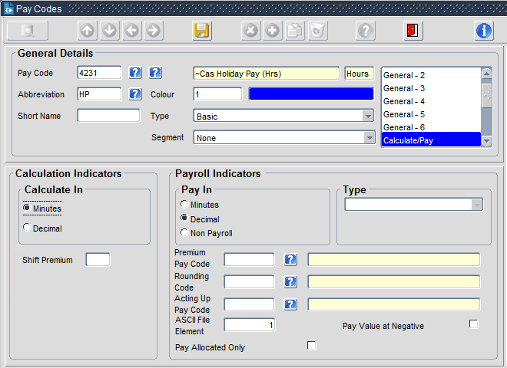
1.3.1.2 Occupational Absence Pay Codes
During the Discovery process, it was decided that only Sick Leave would be recorded using the new configuration.

Sick Leave and other Absence (to be reviewed) will be recorded within the system, however, will not be passed to CorePay.

Maternity, Paternity, Shared Parental and Adoption Leave were de-scoped. All other non-statutory absences were also de-scoped.

The Pay Codes that have been implemented for the Occupational Absence module are:
- Pay Code 2507 – Occupational Absence
- Pay Code 3710 – Sick Leave (New)

Both Pay Codes above have been de-linked from any Sickness – both Occupational and Statutory.

Pay Code 3710 (SICK LEAVE NEW) is a non-pay affecting Pay Code used in the following areas of the system to record Sickness:
- Portal – used in the Team Scheduler to record Sick Leave against an employee
- Record Absence Details (BO-Admin) used to record Sick Leave against an employee
- Occupational Absence Module – determine Sick Leave Entitlements per employee

Navigation: CoreTime/Roster > System Params > Pay Codes
Below is the configuration of the Pay Code in CoreTime:
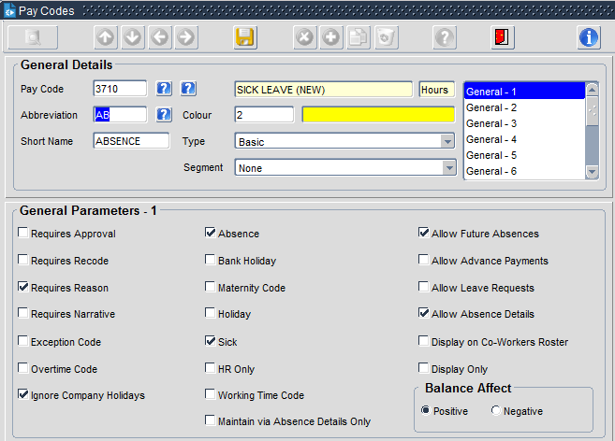
Parameters selected:
- Requires Reason – requires a reason to be populated in both Portal and Back Office applications (see Reason Code Section)
- Ignore Company Holidays – if an employee is sick on a Public/Company Holiday, the system will ignore the Bank/Company Holiday and continue the sick record
- Absence – marked as an Absence
- Sick – marked as Sick Leave
- Allow Future Absences – future Absences may be entered for future dates
- Allow Absence Details – Portal Access to the Pay Code and the Absence Workflow
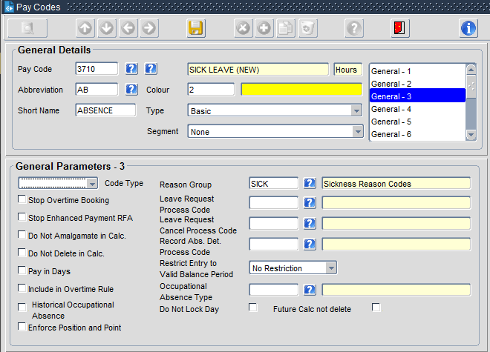
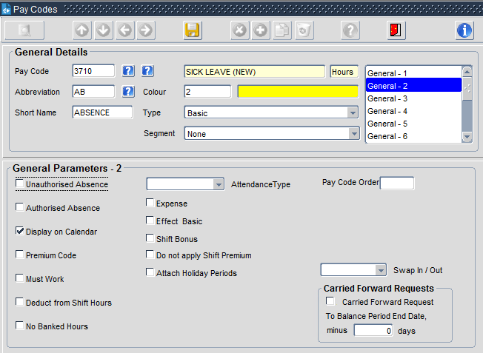

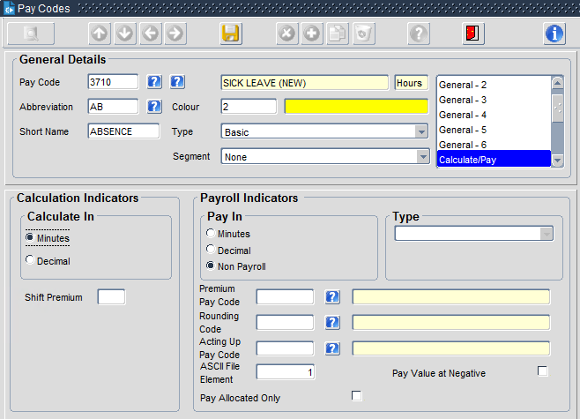
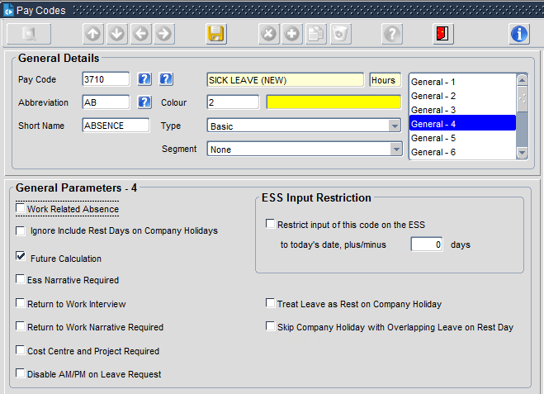

1.3.2 Online Timesheet Claims Pay Codes
During the Discovery process, it was highlighted that certain members of the CASUAL teams should be booking their Hours Worked and Annual Leave to specific Pay Codes relevant to the Post and Job that they are doing.
The Discovery also highlighted that employees would not have access to all CASUAL Pay Codes.
The Pay Codes used for Casual Payments in the existing spreadsheet used by Oxford have been utilised within the Online Timesheet Claims process and are listed below.
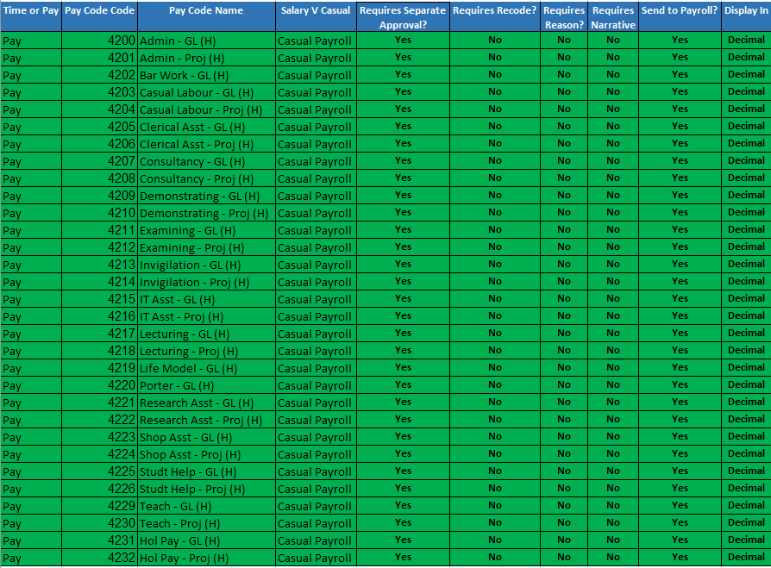

Each of the above has been configured with the following example configuration to allow the Pay Codes to be used within the Online Timesheet Claims process
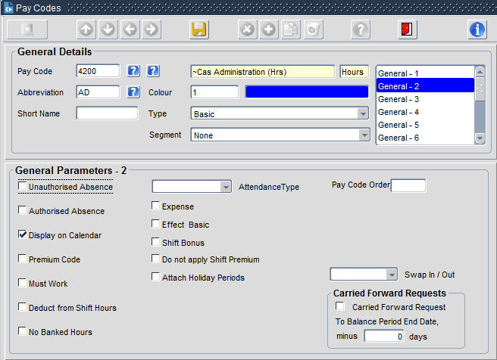
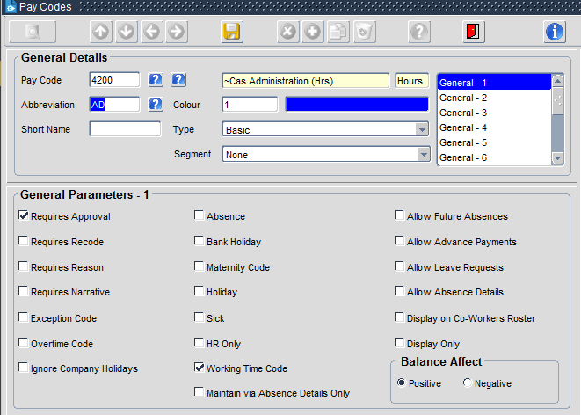

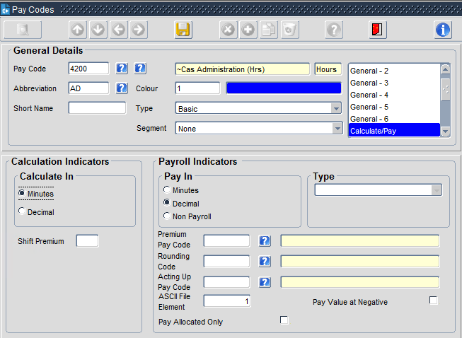
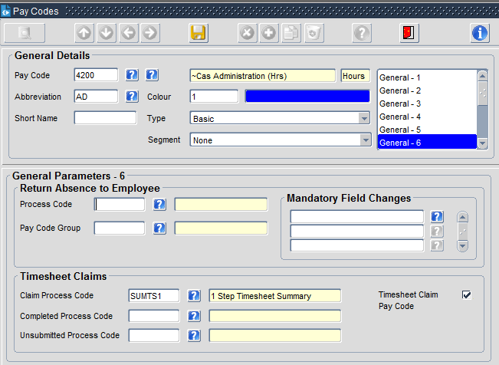

Requires Approval – requires Managers Approval via the Workflow
Timesheet Claim Pay Code – provides the pay code with access to the Workflow
Payroll Indicators – determines this is a Pay Affecting Pay Code
Claim Process Code – allows the Pay Code to use the Workflow

1.4 Reason Codes
When recording Sick Leave either via Portal or via Back Office, a Reason Code is required to better understand the reason for the employees Sick Leave.

The list of Reason Codes configured in the system are as follows:
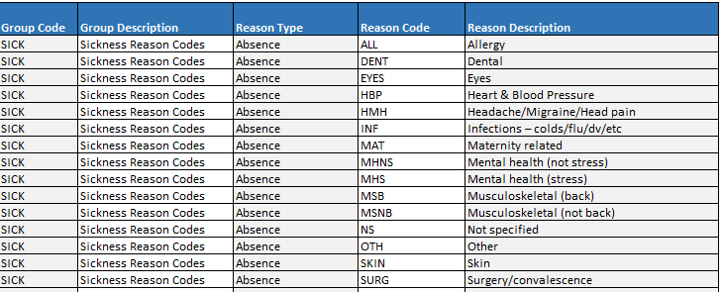

However, as part of the University already use the Absence Recording feature in a slightly different way, the additional reason codes for Absences have been amalgamated into this list.

Navigation: CoreTime/Roster > System Param > Param Q-Z > Reason Codes
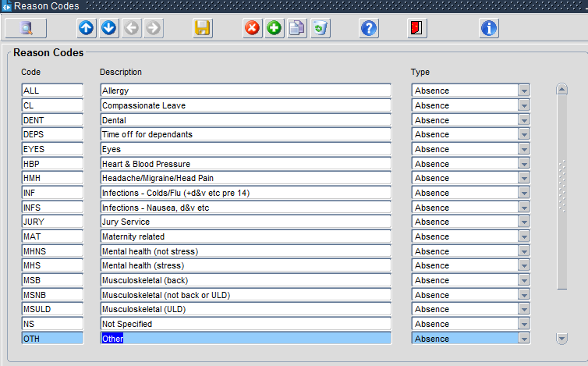

1.5 Personalised Pay Code Groups
As part of the Discovery process, it was highlighted that some Casual employee may reside in the same Work Group (all CASUAL employees in the same Work Group) whilst having an individual set of Personalised Pay Code Groups (PPCGs) relevant to their Post(s). Other CASUAL Employees may be included in other Work Groups.

As part of the project, several different PPCGs have been created to apply at an employee level to each employee. This will allow employee using the Online Timesheet Claim functionality to add hours to the timesheet based on their PPCGs for their Appointment.

An additional set of PPCGs have been created for the Managers to access the hours within the Timesheet for each employee submitting hours using the Online Timesheet Claim process. As the PPCG is the same for each Manager, this has been assigned on both the Work Group (see Work Group Section) and also on the TS_APP Organisational Role within the CoreTime System Users (see System Users)

Any employees who have multiple posts, where the post does not fall within a Department in the Pilot will have a PPCG of OOS – Out of Scope assigned to that post. The OOS PPCG contains no Pay Codes, which will prevent employees from booking time to these Posts until the completion of the roll out.

Example PPCGs can be found below, with the full listing within the Personalised Pay Code Group Tab in the IG.
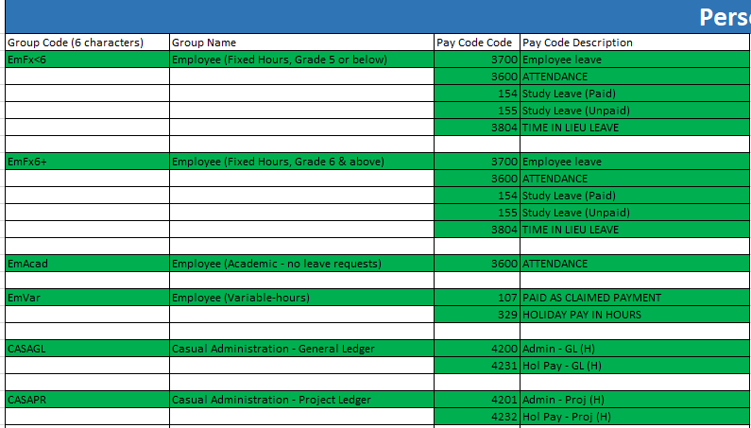

Navigation: CoreTime/Roster > System Param > Param K-P > Personalised Pay Code Groups
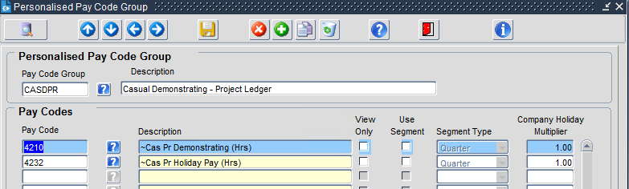

1.6 WTD – Pay Codes
When creating new Pay Codes, the Pay Codes is originally added with Core Pay and then utilised in Core Time (see Pay Code section).

To ensure that the Pay Codes are visible in Back Office, the Pay Codes need to be added into the Maintain Hours and Sign Off Summary (see Sign Off Summary section).
336 – Maintain Hours
029 – Sign Off Summary

Navigation: CoreTime/Roster > System Param > Param Q-Z > Working Time Parameters
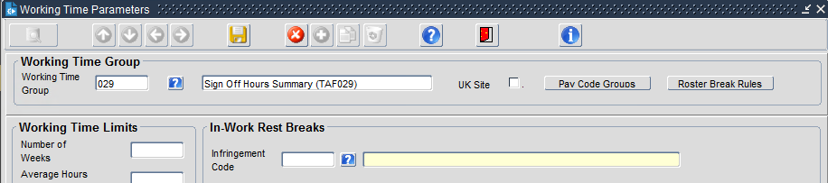
Select Pay Code Groups
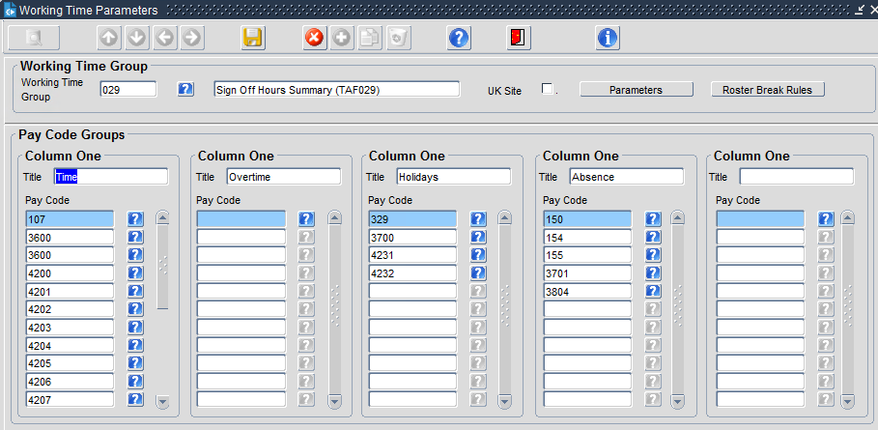
Only when new Pay Codes are added with the Time Module would these need to be updated with any new codes in the relevant columns.

1.7 MSS Summary
In addition to the above section, any newly created pay codes that are going to be used by the Time module will also need to be added to the MSS Summary.
This screen controls which of the Pay Codes Manager can see and Approve and Sign Off.

Navigation: CoreTime/Roster > System Param > Param K-P > MSS Sign Off Summary
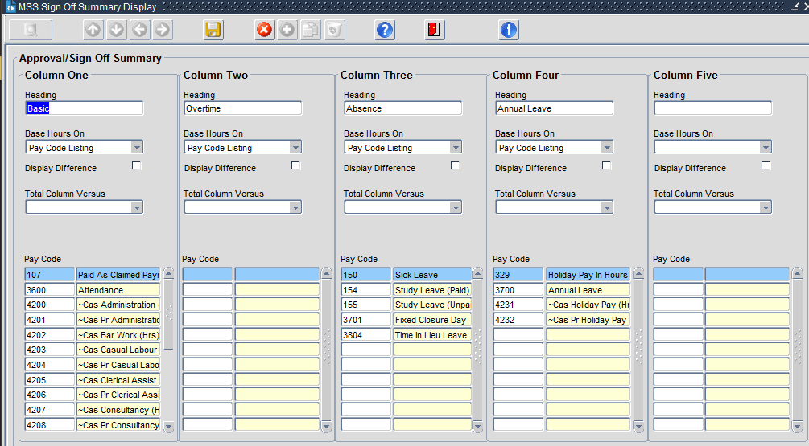
Only when new Pay Codes are added with the Time Module would these need to be updated with any new codes in the relevant columns.

1.8 Work Patterns
A Work Pattern is how the employees’ day is shaped based on a number of hours/minutes worked in a day. Work Patterns are used in the Shift Types to create Shift Types relevant to the employees working week.
Work Patterns are used to determine the number of hours an employee would:
- Be scheduled to work
- Be deducted from an Annual Leave Balance
- Be recorded for Occupational Absence
- Included in the Calendar on the Employee Portal Dashboard

All employee who are not Casual should be awarded a Shift Type containing Work Patterns that are identical to their normal working week. Casuals will be assigned a Shift Type of CASUAL as they will not be recording Absences (see Occupational Absence section) and Annual Leave (see Balances section) is based on an Accrual Balance.

Configured within the system is a Work Pattern for every 5 minute increment between 0 hrs and 12 hrs.
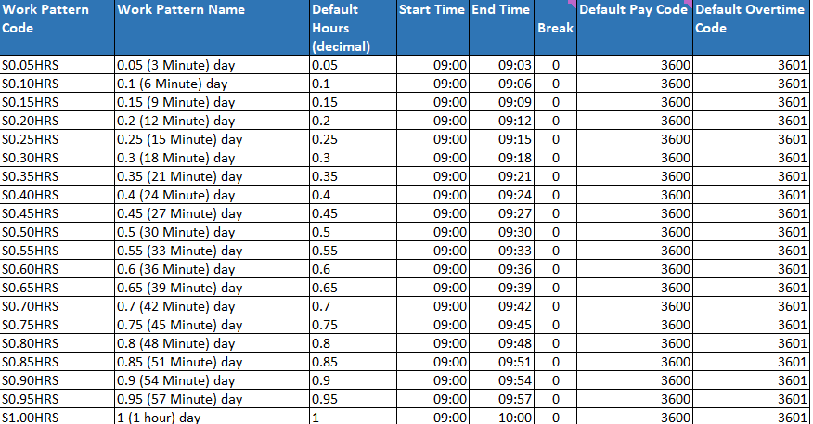

As staff at the University don’t clock in and out, all Start Times have been set to 9am. Each of the Work Patterns also contains a Default Pay Code of 3600 – Normal Attendance, meaning that this will not be passed to Payroll.

Casuals have a Work Pattern of REST, which has been utilised in the Shift Type of CASUAL. This will allow CASUALs to book time withing the Online Timesheet Claims functionality and it pass through to Payroll.

1.9 Shift Types
Shift Types have been configured in the system to apply to employees to determine how their work week is shaped.
Shift Types can be applied as
- Default at Work Group Level meaning that an employee that is added to the Work Group will automatically inherit the Shift Type assigned to the Work Group (see Work Group Section).
- At employee level within the People Management Dashboard

The Shift Types configured within the system will be used by the employees within the Departments for the Pilot but could also be used for the complete roll out if the Shift Type is relevant to the employees work week.
Example Shift Types
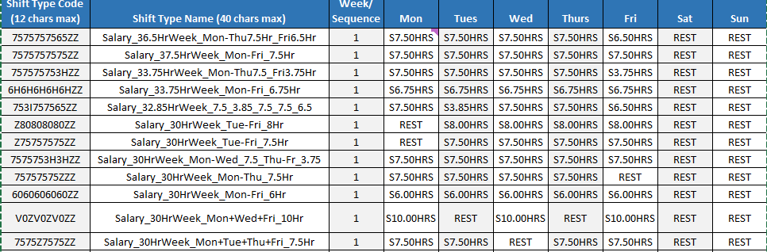

1.10 Work Groups
A Work Group is another term for a group of employees who would primarily have the same:
- Line Manager (Reports to)
- Holiday Scheme
- User Defined Calendar
- Generate Timesheet process
- Shift Type
- Manager Personalised Pay Code Group

Where there are exceptions, these can be overridden at Employee Person Level in either Back Office or the People Management Dashboard (see Person Overrides)

As part of the Discovery process, the Work Groups contained in the four Departments have been notified and updated with the following parameters for the Pilot Implementation:

Navigation: CoreTime/Roster > System Param > Work Groups
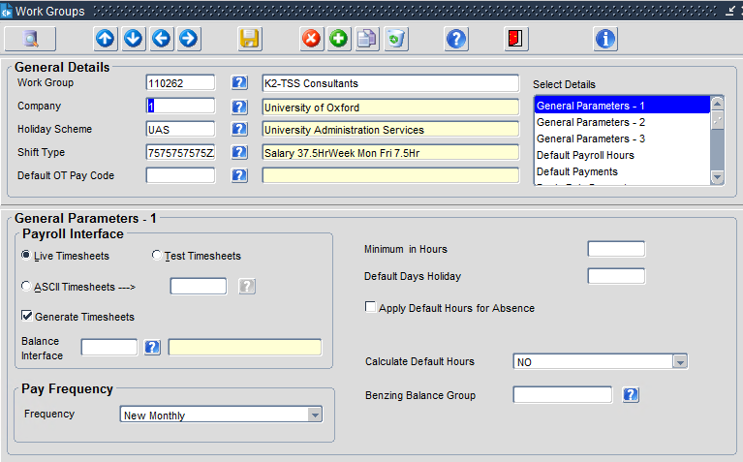
In the screen above, the following parameters have been updated:
Holiday Scheme: default of UAS for all employees in this work group
Shift Type: default of 7.5hrs per day Mon to Fri
Live Timesheets: for use in Timesheets
Generate Timesheets: the Work Group is included in the Generate Timesheet process
Pay Frequency: this Work Group uses the User Defined Calendar of Monthly
Calculate Def Hours: set to ‘No’ as University is not clocking

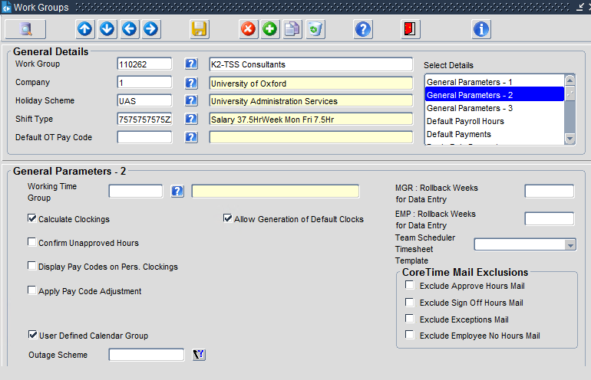
Calculate Clockings: Has to be set by default for use in Timesheets
User Defined Cal Grp: To be selected as using a UDC

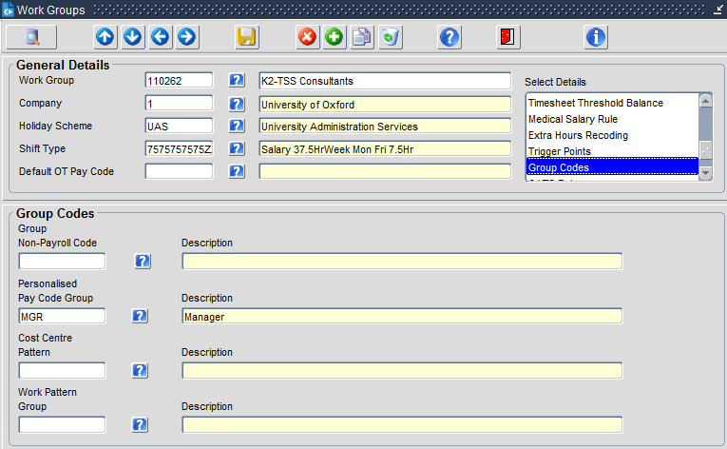
PPCGs: Used to determine the Pay Codes a Manager can see within Portal Timesheets

1.11 Balances
The Discovery process identified five different Balances to accommodate the different Departments in the Pilot. Each Balance has slightly different requirements to accommodate the Employee Annual Leave Entitlements.

The Balances are:
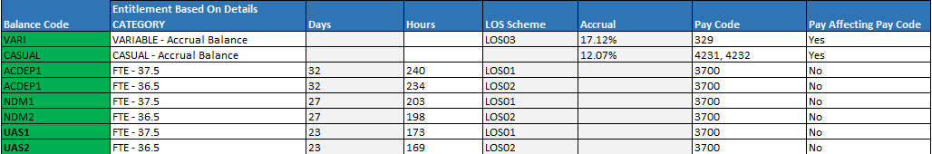

Navigation to the Balance Configuration is found:
CoreTime/Roster > System Param > Balance (all sub menus are from this path)

1.11.1 Balances with Entitlements
For Balances ACDEP1, ACDEP2, NDM1, NDM2, UAS1 and UAS2, the Balances have been configured as an ‘with Entitlements’ type Balance.

1.11.1.1 Balance Parameters
The Balance configuration includes functionality that will not allow employees to enter into negative Annual Leave Balances, Rounding to the nearest .50 (Deci) of an hour.

The calculation of the Annual Leave Balance for a new employee is computed automatically as follows:
Annual Leave Entitlement/365.25 x Number of Calendar Days left in the Annual Leave Balance Year, rounded up to the nearest ½ hour.

Each Balance has been configured to display o the Manager Portal in the following area:
Portal > Manager Dashboard> WFM Page > Balances

1.11.1.2 Balances Calendars
Each of the Balances above have been assigned a Calendar in line with the University’s academic year. The academic year runs from October to September each year.
The system has been configured to 2022, and future years will need to be administered by the University.

1.11.1.3 Balances Entitlements
Each of the above Balances has an entitlement in both Days and Hours, with a Long Service Award assigned to each (see Section 1.11.3 below)
When deploying the Balance to each employee, the University have made the decision to deploy in hours.

1.11.1.4 Balance Pro-Ration
Balance Pro-Ration has been administered in the process to ensure that only employees with an Employee Status of Permanent, Fixed Term, Pensioner, Leaver, Open Ended Externally Funded, Self- Financing and Worker. All other Employment Status Types are excluded from the pro-ration and are not entitled to the Balance.

1.11.2 Balances with Accruals
For Balances CASUAL and VARI, these Balances have been configured differently. These Balances will be assigned to Variable Contract employees and Casual Employees.

1.11.2.1 Balance Parameters
The Balance configuration includes functionality that will not allow employees to enter into negative Annual Leave Balances, Rounding to the nearest .50 (Deci) of an hour.

The calculation of the Annual Leave Balance for a new employee is computed automatically as follows:
Approved Hours in Timesheet x % applied to the Annual Leave Scheme = Total Hours Accrued

Each Balance has been configured to display o the Manager Portal in the following area:
Portal > Manager Dashboard> WFM Page > Balances

1.11.2.2 Balances Calendars
The Balance Calendar is a rolling Calendar and contains the percentage of the Accrual.
In addition, each employee will have a Personal Calendar administered by the University. The dates of the Personal Calendar should be entered at the point of Onboarding or the beginning of a new Appointment.

1.11.2.3 Balances Entitlements
The Balance begins with a zero entitlement and has accrual configuration whereby for each hour recorded in an Online Timesheet Claim, a percentage of those hours is added into the Balance Entitlement.

1.11.2.4 Balances Accrual Pay Codes
For each of the Pay Codes identified by the University for employees to book worked hours against within a timesheet, have also been added into the Accrual Pay Codes within the Balance. This will ensure that for each of the hours booked against a Pay Code contained in the list, a percentage of the hours will be added to the Balance.

1.11.3 Long Service Awards
Long Service Awards have been added to each of the Balances that have an entitlement, along with the Variable Hours Scheme.

1.11.3.1 Long Service Awards for Balances with Entitlements
Each Long Service Award Scheme has been added in hours. The scheme rules are contained within the configuration and also within the IG.
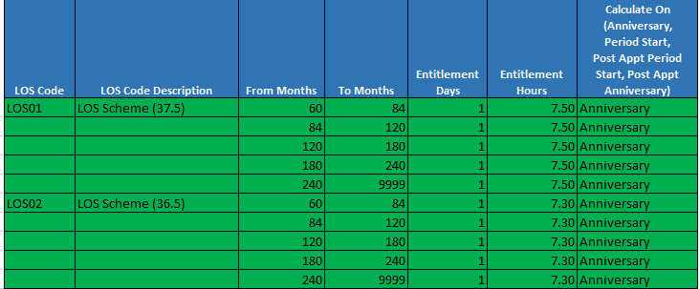

Using the Configuration within the Length of Service Award ‘Balance Param Screen’, the Long Service Awards have been configured as per the example below….. Using Continuous Start Date and Post Appointment Period Start Date.

Scenario:
Jonny begins working for the University on 5th November 2014….
Scheme Year runs from 1st October to 30th Sept……
- Partial Year 2014/2015 – partial year
- Full Year 2015/2016 – Year 1 – waiting year
- Full Year 2016/2017 – Year 2 – waiting year
- Full Year 2017/2018 – Year 3 – waiting year
- Full Year 2018/2019 – Year 4 – waiting year
- Full Year 2019/2020 – Year 5 – waiting year
- Full Year 2020/2021 – Year 6 – qualifying year (looks back to 1st Oct 2020 where 5 yrs Qualify)

1.11.4 Pro rata entitlements
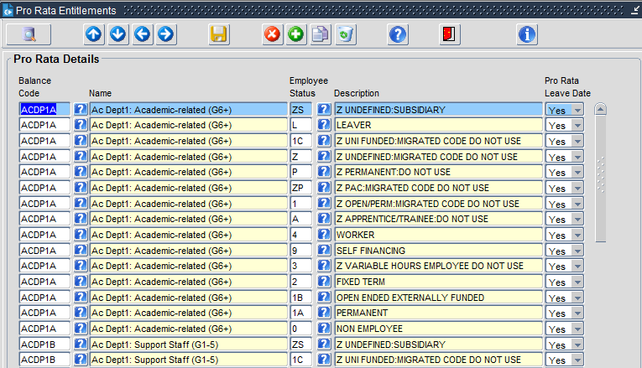
Each balance will require each employee status set up to apply a pro rata starting entitlement. The path to this is:
Coretime/Roster>System Params>Balances>Pro Rata Entitlement

1.12 Holiday Schemes
During Discovery it was highlighted that the different Departments within the University have different Public Holidays and Company Closure Days.
To ensure that employees are treated to these days off, the dates of the Public Holidays and Company Closure Days have been configured into the Holiday Schemes.
The hours relative to these have been deducted from the employee’s entitlement, leaving just the days left to take at their leisure.
There are three different Holiday Schemes for the different Departments and will only apply to those Departments where employees have been granted a Balance with Entitlements.

By adding the Holiday Scheme to the Annual Leave Balance, the system computes the Annual Leave Balance as follows:

Balance Entitlement from Annual Leave Scheme + Public Holidays/Company Closure Days – any days taken = Remaining Entitlement.

The Holiday Scheme dates have been configured in accordance with those provided in the IG. However, this area of the system will require ongoing maintenance for future years for both the Company Closure Days and the Public Holidays.

1.13 Balance Year End
At the end of each Balance Year, the Balance Calendars for all Annual Leave Schemes should be updated to accommodate the future year and in addition, the Holiday Scheme Calendar should be updated with the Public Holidays and Company Closure Dates per Scheme.

Balance Year End should be run on 1st October (immediately after the last day of the previous Balance Year for all schemes that are not a rolling Balance).

Navigation: CoreTime/Roster > Period End > Generate Balance Period End
Please see Documentation on the University for Generating Balance Period End.

2. Person Configuration
There will be, on occasion, the need to override default configuration that has been applied within the Reference Data, so that employees do not inherit the default, but an alternative setting accurate to their employment period.

The application of these overrides can be completed within two areas of the system:
- Back Office – Person Maintenance
- Portal – People Management Dashboard

2.1 Person Overrides
With Back Office, from the Person Maintenance menu option, certain default configuration can be overridden for an employee.

2.2.1 Holiday Scheme Override – Back Office
The Holiday Scheme is configured within the Work Group and will apply to all employees contained within it.
To override the Holiday Scheme to that of a different one, the path is:
CoreTime/Roster > Person Data > Pers Maintenance > locate Employee > Work Group Override
And choose the Holiday Scheme relevant to the employee

2.2 Person Additional Configuration for Time - Portal
When Onboarding an employee, or adding a new Contract, or Changing a Current Contract, there are three additional areas within the People Management Dashboard that will need to be added/updated.

2.2.1 Personalised Pay Code Groups
For each employee included in the Pilot Departments, a Personalised Pay Code Group (PPCG) will need to be assigned to their Personnel Record.
The PPCG should be relevant to the Post that they are performing and not to the Person.
NB: an employee with 4 or 5 different Posts may have 4 or 5 different PPCGs depending on the post they are performing.

2.2.2 Shift Type
For each employee included in the Pilot Departments, a Shift Type will need to be assigned to the employee. If the employees Shift Type is not that of the default set on the Work Group, the Shift Type should be added as part of the Onboarding / Contract Change to reflect their working week.

2.2.3 Balance Entitlement
When Onboarding a new employee, depending on the Department that they are assigned to and their Contractual Hours per week, an Annual Leave Balance should be assigned to their Personnel Record. If the Employee is of a CASUAL / VARIABLE Hours type contract, they should be assigned the appropriate Balance and the Personal Calendar completed within their Personnel Record

2.2.4 Absence Category
Absence Categories are no longer required due to the de-scoping of the Occupational Absence transferring to CorePay

2.3 Organisational Roles by Person
The Organisational Roles by Person determines the roles that are assigned to Managers of Work Groups.
Each non-Pilot Manager should have the Reports to Role as 001 – Manager. This will allow access to the employees of their Work Group

Each Pilot Manager should have a ‘Reports to’ for their Work Group, the Role name being ‘Pilot Manager Absence and Delegation. This will provide the Manager with access to their Employees within Portal.

In addition to this role, if the Manager is looking after employees Annual Leave requests, they will also require ‘Leave Approver’ Role. This will be the standard two roles that should be applied to Managers, unless they wish to re-direct on a permanent basis their Leave Approvals to a dedicated Leave Approver.

In addition to the above, where the Manager of the Work Group is assigned to a Work Group containing some or all employees that will use the new Online Timesheet Claims process, they will have an additional role of TS_APP. This role provides access to allow the Manager to receive Online Timesheet Claims from employees.

2.4 Menu Profiles

2.4.1 Manager Menu Profiles
NON-PILOT MANAGERS
For non-Pilot Managers, the Menu Profile that should be assigned to them is COREPORTAL_MANAGER. The COREPORTAL_MANAGER Menu Profile does not allow access to the Scheduler nor the Absence Module. D

PILOT MANAGERS
There are three new Menu Profiles that have been created for the Managers as part of this Pilot. The two profiles are:
COREPORTAL_LEAVE_APPROVER
COREPORTAL_TS_CLAIM_MGR
As with the Organisational Roles by Person, the COREPORTAL_LEAVE_APPROVER should be assigned to the Manager if they are managing their Employees Leave Approvals, and if they are also managing the Online Timesheet Claims, they should be assigned the COREPORTAL_TS_CLAIM_MGR.

There is one new Menu Profile that has been created for the Managers as part of this Pilot. The new profile is:
COREPORTAL_MANAGER_TIME
The above profile when assigned to an employee will provide access to the following functionality:
- My Approvals (functionality and Widget)
- Manager Timesheet Summary (functionality and Widget)
- Delegation

The COREPORTAL_MANAGER_TIME Menu Profile can also be granted to a non-manager for Delegation purposes by assigning the DEL Organisational Role to a designated employee along with the Work Group they will be a Delegate for. The Menu Profile is assigned during an overnight job triggered by having the relevant Employment Status listed in the Menu Profile Matrix and the employee being assigned the Role of DEL.

2.4.2 Employee Menu Profiles
As part of the Pilot project, additional Menu Profiles have been created for the employees to grant access to the Online Timesheet Claim process, Book Leave and Balance Management. The Menu Profiles COREPORTAL_TS_CLAIM_EMP, COREPORTAL_EMPLOYEE_BALANCE and COREPORTAL_EMPLOYEE_BOOK_LEAVE should only be granted to employees who will be authorised to claim worked hours via the Online Timesheet Claims process, Book Leave or Manage their Balance.

2.5 CoreTime System Users
The CoreTime System User from the original implementation has been continued throughout the T&A implementation process in terms of Manager Access. Additional Configuration of the CoreTime System Users has enabled the TS_APP for the Timesheets and LEAVE for the Leave Approval.
Each of the above have the relevant configuration to allow access to the Managers that have these Organisational Roles applied to their record.

There is only one Organisational Role for 001, LEAVE and TS_APP meaning that if a Manger is to complete this role, they should be granted the role via Maintain Organisational Roles by Person.

There is not a requirement to create a Back Office System User Account per Manager, they will all use the same settings from the Organisational Role.

Employees requiring access to Insight Reporting will need to have a MSS account created using their Employee Number as the Username and the relevant Work Groups the Employee requires access to.

3. Generate Timesheets
The Generate Timesheet process is the ‘interface’ between CoreTime and CorePay where Timesheets within the system for a selected time period are generated and passed to Pay.

The Process for this is based on several areas of the system:
- Work Group having the correct calendar attached
- Work Group enabled for Generate Timesheets
- UDC in the Calendar has the correct open month
- All Timesheets for the period are Approved
- All Timesheets for the period are Signed Off

3.1 Approval Process
The Approval Process has been configured to be administered by the Timesheet Approver in Portal as part of the Online Timesheet Claim Process. The Portal Approval Process will cover both tasks – Approve and Sign Off.

Employees who have Admin access can also Approve Hours if required via Back Office.
Navigation: CoreTime/Roster > Time Management > Approve Hours > add in Calendar
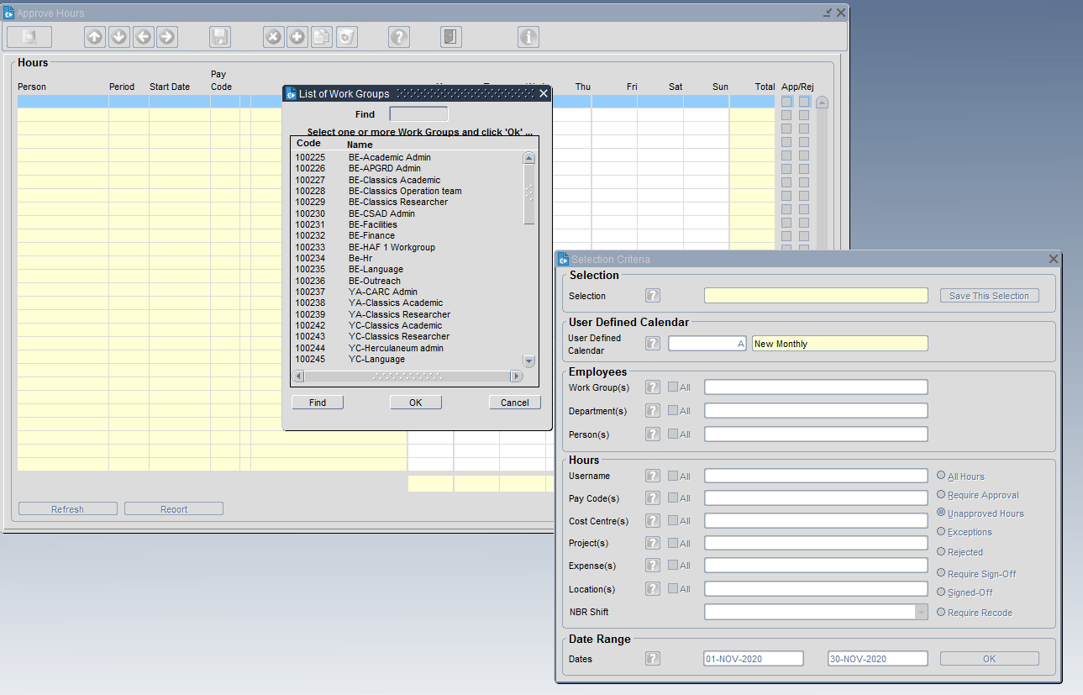

3.2 Sign Off Process
Within the BackOffice functionality, there is provision for Administrators to be able to Sign Off any Unconfirmed Hours that should prevent the Generate Timesheet Process.
For the University, configuration has been requested to allow Unconfirmed Timesheets to ROLL OVER until Approve/Sign Off process has been completed within the Online Timesheet Claim process by the Timesheet Approver.

Navigation: CoreTime/Roster > Time Management > Sign Off Hours
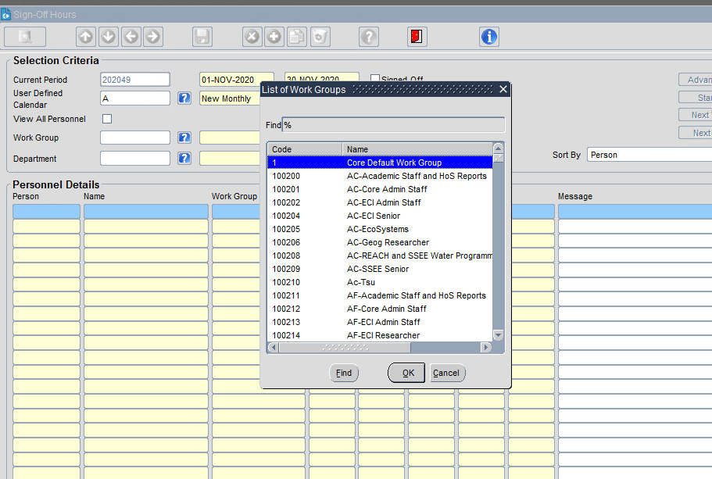

3.2.1 Admin Sign Off in Portal
Sign off for Admins is now available in Portal. For access to this the admin will require:

1. A CoreTime system user with generate timesheets set to All Companies
2. The menu profile WFM_ADMIN_SIGNOFF

The sign off screen is found under WFM Admin Dashboard

Admins can now view any time submissions that have not yet been approved. Admins should either approve and enter a comment saying that an admin has approved the hours or remove the hours submitted and enter their own line of hours. This way would then remove the workflow aspect. Admins can approve and then sign off the hours which will then go through for payment.
If an admin approves the original entry, then bear in mind that the workflow will not drop off the employee or the manager’s dashboard. A manager can approve this workflow at a later date but it will have no impact as the hours had already been paid.

N.B: Admin access in sign off screen is only limited by the system user having generate timesheets on all companies. Admins will see all hours, not just those to the specific work group and department access granted by the system user set up.

3.3 Ignore Unconfirmed Hours (Un-Signed off Hours)
Functionality has been enabled to allow Timesheets that have been submitted within a specific time frame that remain unconfirmed at the point of generating timesheets into pay to be allowed to roll over to the next month.
When rolling the hours into the next month, the system will automatically update the Payroll Period so that the hours are displayed with the new period within the system.
The system uses the ‘Countback’ weeks to determine how many months these hours can be rolled forward for and once exhausted will not include the hours in any roll forward periods.
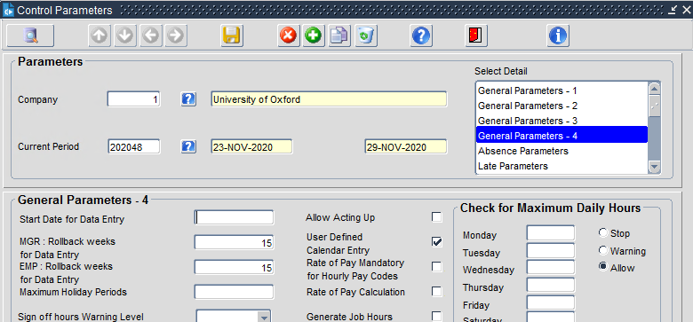

3.4 Generate Timesheet – inc. Ignore Unconfirmed Hours
The Generate Timesheet Process is the process from transferring Online Timesheet Claims from CoreTime to CorePay using a specific set of dates laid out within the User Defined Calendar.
There are two modes of generation – Test and Live explained below

3.4.1 Generate Timesheet – Test Mode
When generating the Timesheet in TEST Mode, the system will automatically draw in all Online Timesheet Claims for the open month within the User Defined Calendar.

In Test Mode, the Generate Timesheet process can be run as many times as required, and for all combinations of Work Groups:
- Single Work Group
- Selection of Work Groups
- All Work Groups.

Once generated and the payroll processes have been run to the stage of Gross To Net, the Timesheets can be seen in the Timesheet area of the Employee Record, or in the Gross to Net Screen.

Navigation: CoreTime Roster > Period End > Generate Timesheets
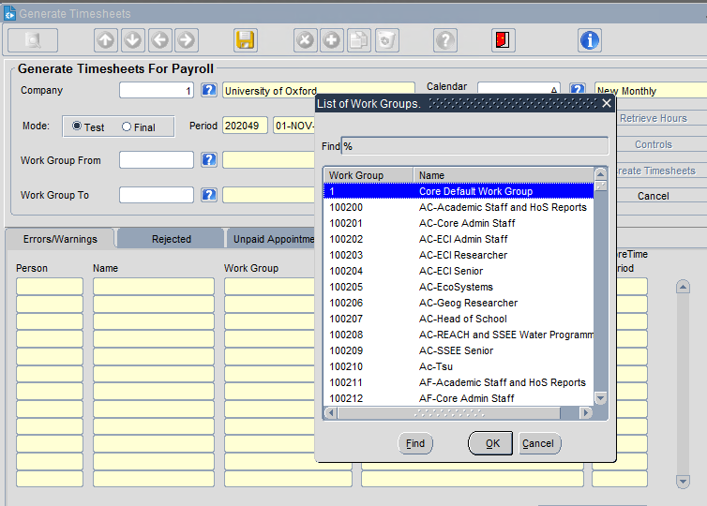

3.4.2 Generate Timesheet – LIVE Mode
The Timesheets should never be generated in LIVE mode until the very last run and all checks have taken place ready for payment.

When the Timesheets are run in Live Mode, the system will:
- Generate the Timesheets for Payment and transfer into CorePay
- Update the User Defined Calendar to the next process period
- Update the CoreTime Input Period for any Unconfirmed Hours

Once the Generate Timesheet process has been run in Live, there is not an option to reverse back to the previous month.

4. Occupational Absence
The Occupational Absence Module that sits between CoreTime and CorePay and transfers the Absences entered by Managers either via Portal or Back Office directly into CorePay has been de-activated.

This will mean that Managers and Admins may record Absences in CoreTime, but they will only be used for recording purposes and will require a report to gain the information.

No calculations relating to entitlement will be performed by the system.

5 Portal Configuration
There are 3 different Portal Dashboards:
- Employee
- Manager (automatically includes the WFM access)
- Administrator

5.1 Employee Dashboard
The Employee Dashboard has 3 static tabs that each employee will receive when onboarded into the University:
- Home Tab
- Pay Tab
- Vacancy Tab

In addition, depending on their employment status, they may be manually granted any number of the following:
- Book Leave
- Balance
- Timesheet
- Calendar (awaiting confirmation if this should be on a separate tab/Menu Profile)

5.1.1 Book Leave
Employees will not automatically receive the Book Leave Tab and Widget as part of the Onboarding process. The Book Leave Tab and Widget is controlled by a Menu Profile called COREPORTAL_EMPLOYEE_BOOK_LEAVE
Once granted, the Book Leave Tab and Widget will appear on the Employee Dashboard.

Within the Book Leave Tab, the Book Leave Widget has been configured as follows:
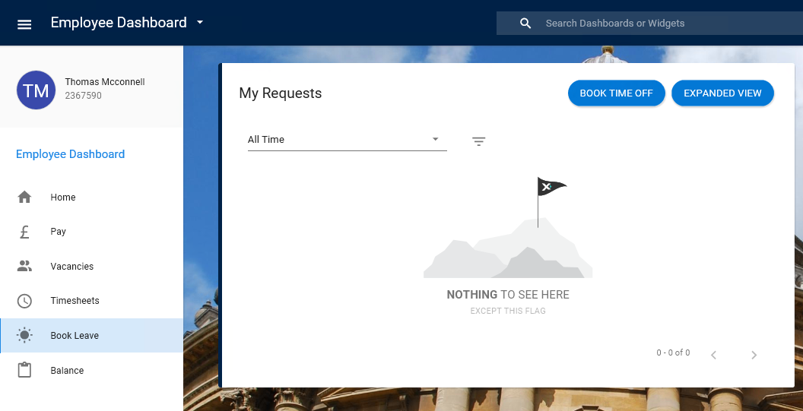

There are no further Menu Options to be removed and the Widget should contain the options to Book Time Off and Expanded View.

5.1.2 Balance
Employees will not automatically receive the Balance Tab and Widget as part of the Onboarding process. The Balance Tab and Widget is controlled by a Menu Profile called COREPORTAL_EMPLOYEE_BALANCE
Once granted, the Balance Tab and Widget will appear on the Employee Dashboard.

Within the Balance Tab, the Balance Widget has been configured as follows:
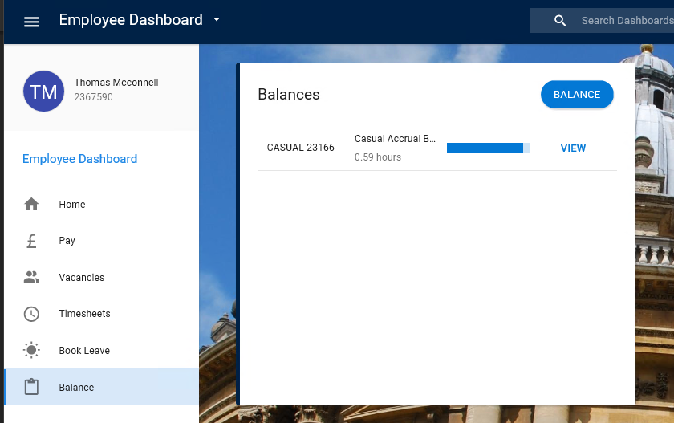

5.1.3 Timesheet
Employees will not automatically receive the Timesheet Tab and Widget as part of the Onboarding process. The Timesheet Tab and Widget is controlled by a Menu Profile called COREPORTAL_TS_CLAIM_EMP
Once granted, the Timesheet Tab and Widget will appear on the Employee Dashboard. In the background, the ‘My Work Week’ is enabled to allow the Timesheet to work, but the ‘My Work Week’ remains hidden from the employee.

Within the Timesheet Tab, the Timesheet Widget has been configured as follows:
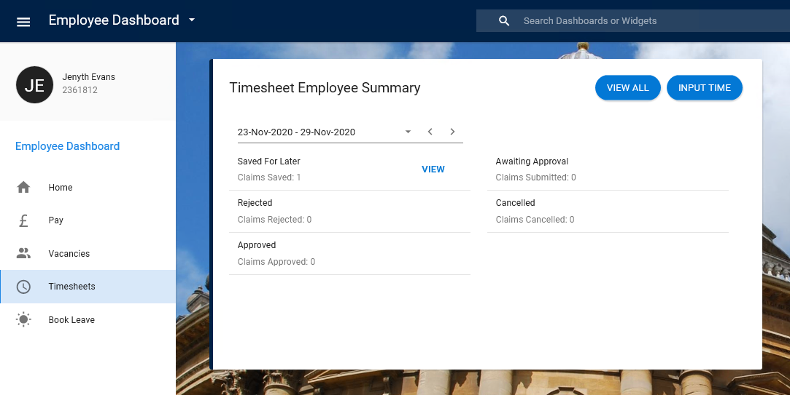

From INPUT TIME, the following screen appears
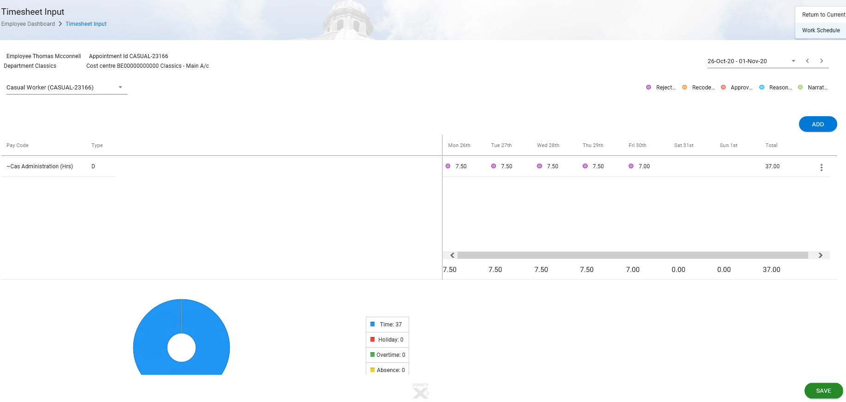

From the ACTIONS Tab:
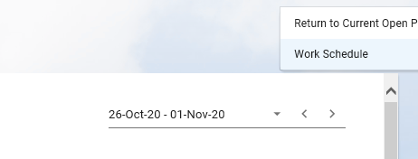

Legend:
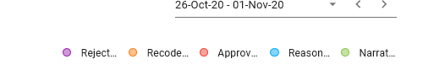

5.2 Manager Dashboard
The Manager Dashboard has 1 static tab that each Manager will receive when onboarded/promoted to a Work Group Manager within the University:
- Home Tab
Each Manager should have both the COREPORTAL_MANAGER and COREPORTAL_LEAVE_APPROVER as standard Menu Profiles

If they are a Manager of a Work Group that contains Casual/Flexible employees, they will also be given an additional Tab:
- Timesheets

The Timesheet Tab is controlled by applying the Menu Profile of COREPORTAL_TS_CLAIM_MGR

5.2.1 Home Tab
The Home Tab will contain 2 Widgets:
- My Team
- My Approvals

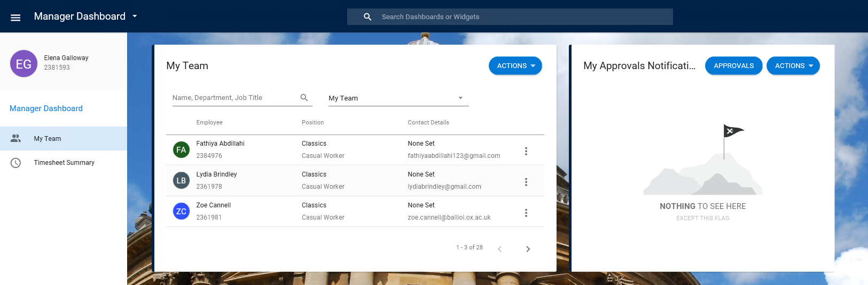

The My Team Widget will have just one options from the Actions Tab > View Scheduler
From the Ellipsis by each of their employees’ names will provide details of the employee to the manager. For Time Management, only the Balance Information will be available to view.

The My Approvals Widget will allow the Manager to Approve and Reject the Annual Leave requested by Permanent/Fixed Term Contracts only (Annual Leave for Casual/Variable employees will be submitted via Timesheets).

5.2.2 Timesheet Tab
The Timesheet Tab contains 2 Widgets:
- Timesheet Summary
- Delegation
allowing the Manager to access the Timesheets submitted by employees and to Delegate their duties if required.
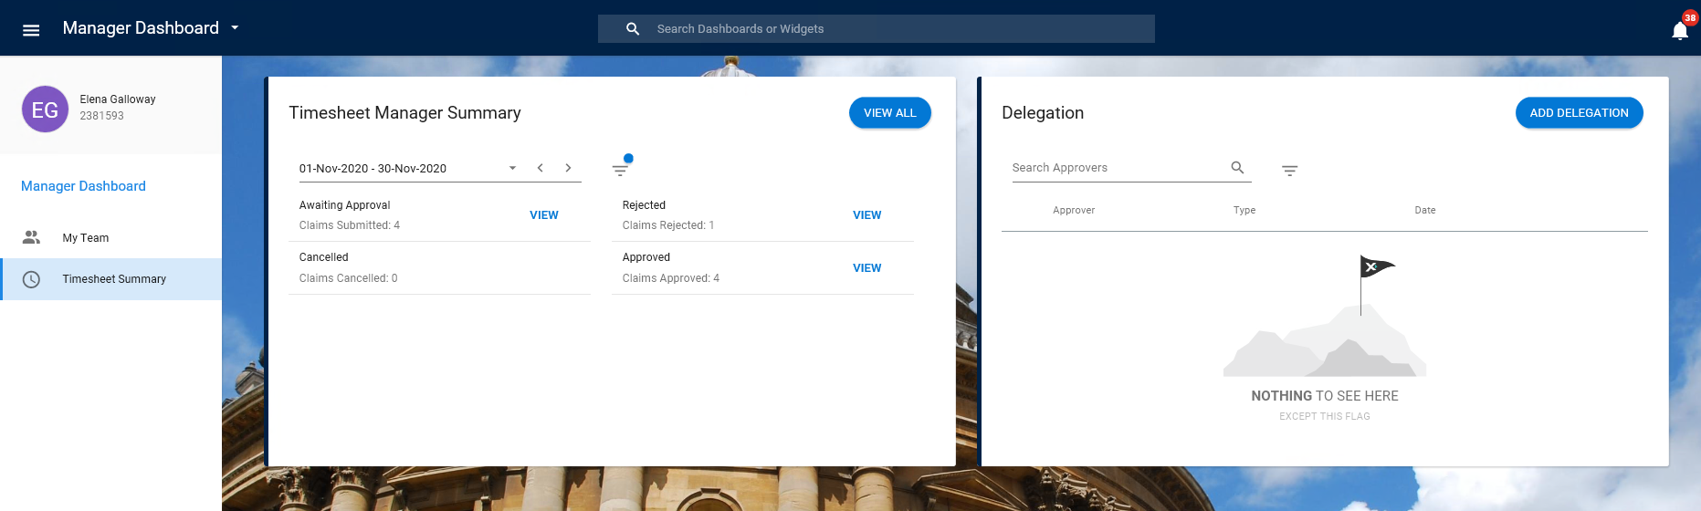

The Timesheet Manager can access Timesheets awaiting Approval and also see the Timesheets that have previously been approved/Rejected.

The Dates displayed in the Calendar are the dates that relate to the open period in the Back Office UDC.
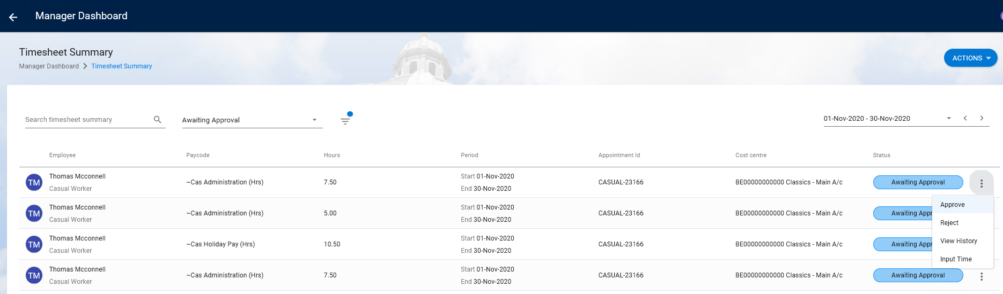

From the Approval Required option, the Manager will be able to see all Timesheets awaiting approval. The ellipsis at the side of each employee will allow the Manager to view the Timesheet (Input Time), see the History, Approve and Reject the Timesheet

By highlighting all Timesheets and selecting the ACTION button will group the Timesheets together.
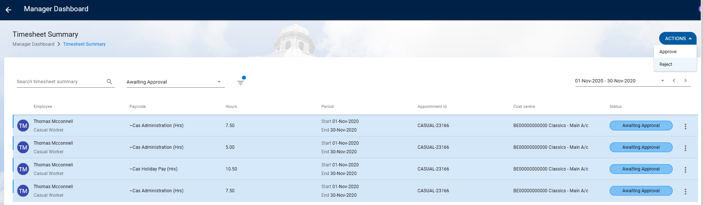
Allowing bulk Approval/Rejection of all Timesheets.

5.2.3 Delegation
The Delegation Widget will allow for the Organisational Role duties and the Timesheet Approver duties to be delegated to other Managers / Team Members respectively.

Only the Role and the Timesheet Approver options should show on the drop-down menu
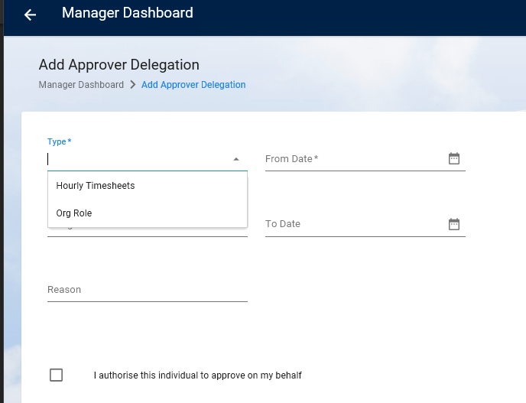

Managers should be able to delegate by adding the relevant data into the fields.

